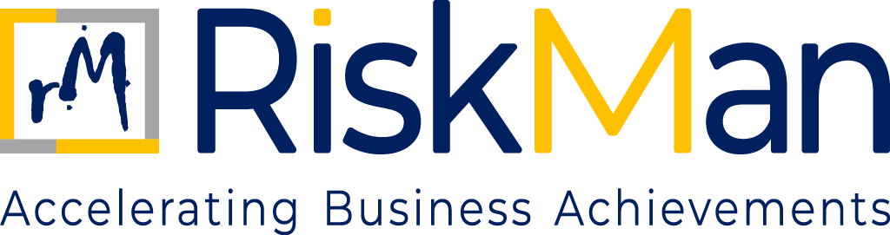
DATA PRIVACY POLICY
TABLE OF CONTENTS

DATA PRIVACY POLICY

- Objective…………………………………………………………………………………………..…………………………………….3
- Scope…………………………………………………………………………………………………..………………………………....3
- Governance and Oversight………………………………………………………………………………………………………3
- Data Privacy Principles…………………………………………………………………………………………………………….3
- Lawful Processing of Personal Data…………………………………………………………………………………………4
- Information Security Controls…………………………………………………………………………………………………4
- Third Party and Cloud Security……………………………………………………………………………………………….4
- Incident and Breach Management………………………………………………………………………………………….4
- Roles and Responsibilities……………………………………………………………………………………………………….5
- Awareness and Training………………………………………………………………………………………………………….5
- Record Retention and Data Disposal……………………………………………………………………………………….5
INFORMATION SECURITY & DATA PRIVACY POLICY
- OBJECTIVE
The objective of this Information Security & Data Privacy Policy (“Policy”) is to establish a unified and structured framework for safeguarding information assets and personal data handled by RiskMan Consulting LLP (“RiskMan” or “the Firm”).
This Policy aims to:
- Protect the confidentiality, integrity, and availability of information assets
- Ensure lawful, fair, and secure processing of personal data
- Manage cyber security risks arising from the Firm’s consulting and professional activities
- Demonstrate the Firm’s commitment to information security, data privacy, and stakeholder trust
- SCOPE

This policy applies to all individuals and entities associated with RiskMan Consulting LLP. It covers all employees, including those who are permanent, contractual, or interns, as well as partners, consultants, and associates who are professionally engaged with the Firm. Additionally, the policy extends to clients, suppliers, vendors, and any other third-party stakeholders who interact with or are connected to the operations and business activities of RiskMan in any capacity.

- GOVERNANCE AND OVERSIGHT

The Partners have overall responsibility for information security and data privacy governance, including:

- Approval of the information security and data privacy framework
- Oversight of material cyber security and data protection risks
- Review of significant incidents or breaches.
Senior management is responsible for:
- Implementing appropriate security and privacy controls
- Monitoring compliance with this Policy
- Escalating material risks or incidents to the Partners in a timely manner

- DATA PRIVACY PRINCIPLES
RiskMan manages information security and data privacy in accordance with the following principles:
- Information and personal data shall be protected against unauthorised access, disclosure, alteration, or loss
- Personal data shall be processed lawfully, fairly, and transparently
- Data shall be collected only for legitimate and specified purposes
- Access to information shall be restricted on a need-to-know basis
- Appropriate safeguards shall be applied proportionate to risk
- Security and privacy considerations shall be embedded into business and engagement processes
- LAWFUL PROCESSING OF PERSONAL DATA
Personal data shall be processed only where there is a lawful basis, including:
- Consent of the individual, where required
- Performance of contractual obligations
- Compliance with legal or regulatory requirements
- Legitimate business purposes permitted under applicable data protection laws
Personal data shall not be processed for purposes incompatible with the original intent of collection.
- INFORMATION SECURITY CONTROLS
The Firm shall implement reasonable technical and organisational measures to protect information assets, which may include:
- Role-based access controls and authentication mechanisms
- Secure configuration and maintenance of systems and devices
- Protection against malware and unauthorised activity
- Secure storage and transmission of sensitive information
- Backup and recovery arrangements to support business continuity
Specific technical configurations are managed internally and are not publicly disclosed.
- THIRD-PARTY AND CLOUD SECURITY
Where third-party service providers or cloud platforms are used, the Firm shall:
- Assess information security and data privacy risks associated with such arrangements
- Ensure appropriate contractual safeguards, including confidentiality and data protection obligations
- Restrict third-party access to authorised purposes only.
Third-party arrangements shall be monitored commensurate with risk.
- INCIDENT AND BREACH MANAGEMENT
Any actual or suspected cyber security incident, unauthorised access to information, or personal data breach shall be:
- Reported immediately to respective managers
- Assessed to determine impact and severity
- Contained and remediated promptly
- Escalated to Partners where it is material
Where required by law, appropriate notifications shall be made to affected individuals or regulatory authorities.

- ROLES AND RESPONSIBILITIES

- Partners: Provide oversight and strategic direction for information security and data privacy.
- Senior Management: Implement controls, monitor risks, and manage incidents.
- All Personnel: Protect information and personal data and comply with this Policy and related requirements.
Failure to exercise due care in handling information may expose the Firm to significant risk.
- AWARENESS AND TRAINING
RiskMan promotes information security and data privacy awareness through induction programmes for new personnel and periodic communication or training initiatives.
Personnel are expected to remain vigilant against information security and privacy risks, including cyber threats and social engineering.
- RECORD RETENTION AND DATA DISPOSAL
Information and personal data shall be:
- Retained only for legitimate business or legal purposes; and
- Securely deleted, destroyed, or anonymised when no longer required.
Retention and disposal shall be carried out in accordance with applicable laws and internal policies.

